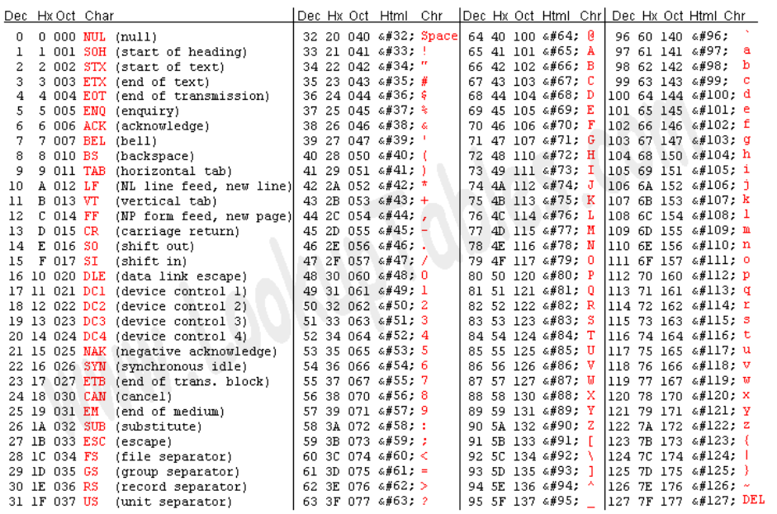He use the American code of ASCII code to represent text.

Standard ASCII uses 7 bits.

7 bit ASCII was originally developed for use with fax machines. It can only represent 127 characters and is not therefore useful for international languages.

To solve this extract ASCII is used. This makes full use of all 8 bits.

Unicode takes this idea further bb using 2 bytes for characters.

Android